Feature image: "Spot the Real Deal Before You Buy!"

Make slug for this post: how-to-authenticate-used-luxury-watch

Title: How to Authenticate a Pre-Owned Luxury Watch Before You Buy
Focus Keyword: Pre-Owned Luxury Watch

Secondary Keyword:
Pre-Owned Rolex Watches
Used Omega Watches
Certified Pre-Owned Cartier Watches
TAG Heuer Secondhand Watches
Pre-Owned Breitling Timepieces

Make gmb post and a meta description.

Internal link:
Luxury watches: https://swissiceco.com/pages/watches

Meta Description:
Want to spot Pre-Owned Luxury watches and avoid fakes? Learn expert tips to authenticate pre-owned Rolex, Omega, Breitling, TAG Heuer & more.
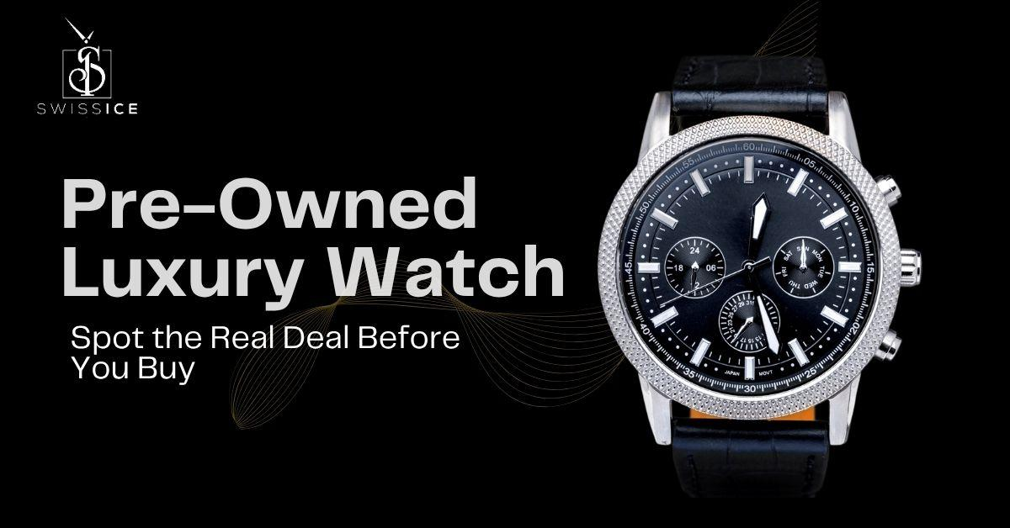

How to Authenticate a Pre-Owned Luxury Watch Before You Buy H1
That heart-pounding moment you spot the pre-owned luxury watch? Pure excitement. Then... the doubt creeps in. "Is this real?" We’ve all been there. You’re not just buying gears and springs, but you’re bringing home a piece of history, incredible craftsmanship, and let’s be real, a serious investment. Get it wrong, and it stings.
At Swiss Ice Co, this is our whole world. We’ve held thousands of Pre-Owned Luxury Watches (and spotted the fakes). We know the joy of a perfect find and the ache of a scam. So we made this guide for you. This is your friendly cheat sheet for spotting the real deal. Consider it your backstage pass to buying with confidence.

Start With Your Eyes and Hands H2
Forget lab equipment for now. Your best tools? Your own two eyes and those trusty fingers to find the real Pre-Owned Rolex Watches or any other model of watches.

Feel That Weight H3
Grab the watch. A real luxury piece has presence due to its solid steel, maybe gold, that tough sapphire crystal. It shouldn’t feel feather-light or hollow, like cheap plastic pretending to be metal. That satisfying, quality weight? Good first sign.

Check Every Edge H3
Luxury brands sweat the tiny stuff. Run your thumb gently along the case sides, bracelet links, and clasp on your favorite Certified Pre-Owned Cartier Watches, Rolex Watches, or any other model watches. Genuine pieces feel flawlessly smooth and polished like glass or brushed perfectly even. Rough spots, wobbly polishing, or scratches that seem deeper than wear? Big red flag. Open and close the clasp. It should feel solid, not flimsy.

Get Up Close With the Dial H3
This is where imposters often slip up. Use a bright light and a magnifier (your phone’s zoom works in a pinch!).
- Text & Logos: Peer at the brand name and model text. Letters should be razor-sharp, perfectly straight, and crisp. Blurry, uneven, or slightly drunken-looking printing?. So, before you buy your dream TAG Heuer Secondhand Watches or any other brand watches, you should check the logo & text authenticity.
- Markers & Hands: Hour markers sit perfectly straight. Lume (that glow stuff) or tiny gems should be flawless. Hands? Silky smooth, no rough bits.
- Date Window: Check the magnifier (like Rolex’s 'Cyclops'). Is the date centered? Does the number fill the window nicely? Weak magnification or misalignment screams trouble.

The Tap Test H3
Real luxury watches use a super-hard sapphire crystal. Gently tap it with your fingernail. Hear a high, clear ping? Good. A dull thud? Likely, cheap glass or plastic is a common fake giveaway.

Crack the Watch's Secret Code H2
Every real luxury watch has its own ID numbers, which are usually hidden. Finding them is step one.

Where to Look H3
It depends on the brand! Like in the case of Pre-Owned Breitling Timepieces, it is often inserted:
- Between the lugs (where the strap attaches) at 6 o'clock (might need to remove the strap).
- Tiny-etched around the inner dial edge (common on newer Rolex).
- On the back (less common now) or inside the back (needs opening!).

Look HOW It's Done H3
Don't just write down the digits. Stare at the engraving itself.
- Real Deal: Looks like a master engraver did it. Deep, clean, sharp, and perfectly even. The font matches the brand exactly.
- Fake Alert: Often shallow, messy, uneven, or uses a weird font. It might look fuzzy like acid burns, or just poorly stamped.

Do Some Digging (Carefully!) H3
Got the numbers? Google that exact model. Does the serial number make sense for when it was made? Does the model number match the watch you see? But be smart because sometimes databases aren't perfect, and numbers can be copied. How it looks is often more telling than the number itself.

The Heart and Soul Inside H2
This is where the magic lives and where fakes struggle most. Peeking inside usually needs a pro (we strongly recommend one).

It's All About the Details H3
Real luxury movements are breathtaking close up.
- Look for beautiful swirls (perlage), elegant stripes (Geneva stripes), shiny angled edges, and those gorgeous blue screws. Faking this well costs too much.
- Any writing on the moving parts (rotor) or plates? Should be sharp, deep, and perfect. Blurry or shallow engravings? Bad sign.
- Listen. The rotor (that spinning weight) should whirr smoothly. Grinding or rattling? Trouble.

Does it Actually Work? H3
Keep time over a day? Does the stopwatch start/stop/reset cleanly? Date snap over at midnight? Real luxury moves with silent precision. A stumbling seconds hand or sticky buttons scream "fake."

Let's Be Honest H3
Are you this kind of expert in verification? It's hard. Unless you're a serious tinkerer with special tools, this is why experts like us exist. At Swiss Ice Co, we open every single watch. Our watchmakers breathe this stuff.

Papers Tell a Story H3
Original docs are golden, but they can be faked too.
- The Box: Nice, but often copied. A mint box for a 20-year-old watch? Sometimes fishy.
- The Real Stars: Warranty Card & Papers
- Real: Feels quality. Model and serial numbers match the watch perfectly. Look for holograms, official dealer stamps, and purchase dates. Check the dealer name?
- Fake: Often feels thin or cheap. Blurry print, weird fonts, spelling mistakes, missing security bits. Serial number scribbled by hand? Don’t buy.
- Service History Gold: Receipts from known watchmakers or brand service centers? Jackpot. They list the serial number and work done. Consistent care by pros adds huge trust points.

Listen to Your Inner Feelings: H3
Trust that gut feeling. If something feels weird, it probably is. Watch out for:
- Too Good to Be True Price: If it’s wildly cheaper than everywhere else? Alarm bells. Real luxury holds value.
- Missing or Sketchy Papers: No docs? Or papers that look photocopied and blurry? Big caution sign.
- Shady Seller Vibes: Dodgy about the watch's past? Pushing you to buy now? Can't provide clear photos? Only on sites with no address or reviews? Walk away.
- Sloppy Work: Crooked markers, glue visible, a bracelet that rattles, a bezel that doesn't line up? Not luxury.
- Details That Don't Add Up: Does the model number not match the style? Did dial color ever make for that watch? Research is your friend here!

Swiss Ice Co Makes It Simple and Safe H2
Okay, truth time. Even with this guide, spotting a super-fake yourself? Really, really tough. The forgers are getting scary good. That nagging worry? You don't need it.
That's why Swiss Ice Co exists. We don't flip watches, but we guarantee them. All the Used Omega Watches or Rolex or any other model watches that we sell get the complete treatment from our watchmaker dream team. What does that mean for you?
- Eagle-Eyed Inspection: Every inch, under pro lights and loupes.
- Inside Look: We open it. We study the movement. We match it to factory specs.
- Number Crunching: We verify serials and study how they're engraved.
- Paper Trail: We authenticate the documents.
- Test Drive: We check timekeeping and every function.
- Brand Whisperers: We know Rolex, Omega, Cartier, TAG Heuer, Breitling secrets.
What You Get With Swiss Ice Co:
- Proof It's Real: Your own detailed authenticity report.
- We've Got Your Back: A solid warranty because we trust what we sell.
- Breathe Easy: The genuine article, verified by obsessive experts.

Ending Note: H3
Finding your perfect pre-owned luxury watch should be pure joy, not nail-biting stress. You deserve that thrill. Knowing these tips makes you smarter, sharper.
But for total peace of mind? Partner with people who live this. For Swiss Ice Co, authenticity isn't a checkbox, but it's our heartbeat. We eat, sleep, and breathe authentic watches. We take on the risk, so you get only the reward.
Ready to fall in love with your next watch, completely worry-free? Discover the Swiss Ice Co collection today. Find your perfect piece, backed by proof and passion.
GMB Description:
That sinking feeling when you spot a pre-owned Rolex, Omega, or Cartier, wondering whether it is real or not? We get it. Buying secondhand luxury should thrill you, not keep you up at night. You’re investing in legacy and craftsmanship, and fakes are scarily good these days. Breathe easy: our brand new guide spills everything we’ve learned about authenticating thousands of watches. Learn how to feel the weight of real metal, spot perfect engraving tricks, decode serial numbers like a pro, and catch brand-specific secrets (like Cartier’s hidden signatures or Omega’s tiny laser mark). We’ll show you red flags like too-good prices, shaky paperwork, and sloppy details so you shop smarter. But honestly? Spotting super-fakes alone is challenging work. That’s why at Swiss Ice Co, our master watchmakers open and inspect every single pre-owned watch that crosses our bench. We study the movement under bright lights, test every function, verify papers, and obsess over details so you don’t have to. Every piece comes with proof of authenticity and our warranty for your real peace of mind. Stop stressing and start wearing confidence. Read the complete guide now and discover how to buy your dream watch without doubt.

